Name: Sapargali Temirlan
Group: SE-2403
Instructor: Kozhakhmet Zhaksylyk
PART 1 TASK 2
Deriverables
LogicV1.sol, LogicV2.sol, deployment scripts are in their respective files/folders.
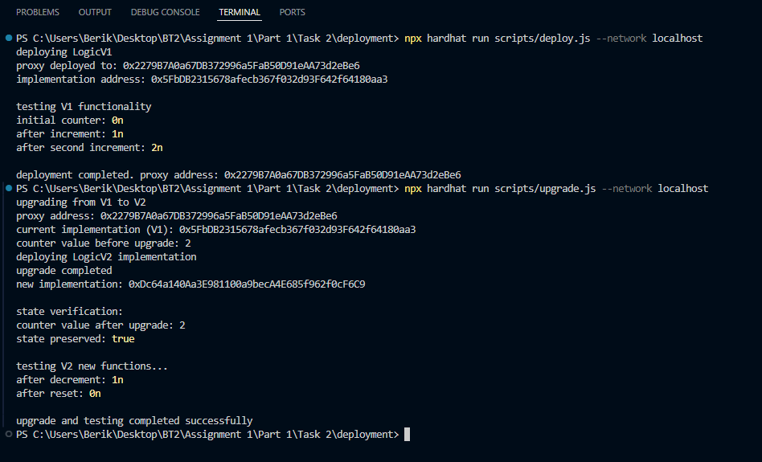

Explanation
Proxy Pattern Architecture
The UUPS pattern consists of three main components:
Proxy Contract: Stores the implementation address in a storage slot (ERC1967_IMPLEMENTATION_SLOT) and forwards all calls via delegatecall
Implementation Contract: Contains the business logic but never stores state independently
Storage Layout: State variables are stored in the proxy's storage, not the implementation
Call Flow
User to Proxy Contract to delegatecall to Implementation Contract
to Storage (Proxy)
When a user calls the proxy:
The proxy's fallback() function receives the call
It uses assembly to delegatecall to the implementation address
The implementation code executes but modifies the proxy's storage
Results are returned to the user
Storage Layout Risks
Critical Issue: Storage layout must be consistent across versions
// V1 Storage
slot0: uint256 counter
slot1: address _owner (from Ownable)

// V2 must maintain same layout
// Correct V2
slot0: uint256 counter // Same position
slot1: address _owner // Same position

// Wrong V2 (would corrupt storage)
slot0: uint256 newVar // This would overwrite counter
slot1: uint256 counter // Actually points to _owner slot
Best Practices:
Always append new variables at the end
Never reorder existing variables
Never remove variables (can mark as deprecated)
Use __gap array to reserve future storage slots
Why Initializers Replace Constructors
Constructors don't work in upgradeable contracts because:
Implementation Isolation: Implementation contracts are deployed separately and their constructors run during deployment, but they never affect the proxy's state
Single Initialization: The proxy state must be initialized only once. Using a constructor would run during implementation deployment, which doesn't affect the proxy
Security: Initializer functions prevent multiple initializations (unlike constructors) through the initializer modifier
// Won't work in upgradeable contracts
constructor() {
owner = msg.sender; // Sets owner in implementation, not proxy
}

// Correct approach
function initialize() public initializer {
__Ownable_init(msg.sender); // Sets owner in proxy storage
}

